Join Keith and Leigh Ann on these fabulous back-to-back cruises Down Under.
If you can’t do both, then pick one.

Great Barrier Reef Cruise

Celebrity Eclipse

March 26, 2022- April 6, 2022
Round Trip , 11 Nights , 6 Ports , 4 Sea Days 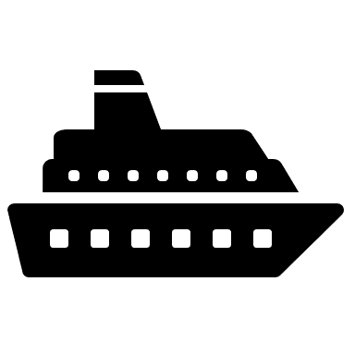

This journey to the Great Barrier Reef—home to the most beautiful and vibrant aquatic ecosystems of the world—offers so much more than the largest coral reef on Earth. Visit the lush foliage of the Daintree Rainforest. In Brisbane, discover cultural sophistication mixed with exotic wildlife including koalas, wombats, and blue-tongued lizards. Experience all of this and more on an amazing adventure along the eastern cost of Australia.

Cruise Itinerary
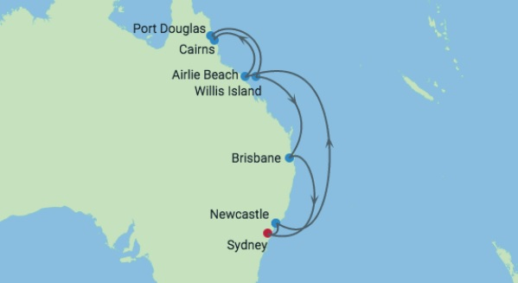

March 26 – Depart Sydney at 6:45 pm. Considered one of the most cosmopolitan cities in the Southern Hemisphere, Sydney offers so much—from beaches and wineries to stunning landmarks and world-class shopping. Sightseeing options include architectural marvels like the Sydney Opera House and the Sydney Harbor Bridge. View life below the surface from Sydney Aquarium’s underwater walkways or take it all in from above on a tour of the Sydney Tower. Well-known surf beaches, zoos, national parks, whale watching tours, bush tours, and the Royal Botanic Gardens offer visitors a chance to enjoy the area’s sunshine, lush greenery, wildlife, and clear blue oceans. Sydney is also one of the most ethnically diverse cities on the globe, offering a wealth of cuisines, unique museums, and cultural opportunities. Explore lively pubs, shops, and historic buildings at The Rocks, located on Sydney harbor.
March 27 – Newcastle, Australia- Named for England's famous coal port, Newcastle cruise offers history, stunning surf, a relaxed urban atmosphere, and is the gateway to Australia’s wine country. Near the port, stroll through 200 years of local history and visit the Customs House, now a restaurant and bar. Watt Street still has buildings from the convict era when Australia was a penal colony for England. Christ Church Cathedral with its magnificent stained-glass windows dominates the skyline. For military history—and breathtaking Pacific views—venture out to 19th-century Fort Scratchley. There you can also relax on the famous sunny beaches—Nobbys Beach, Bar Beach, and Merewether Beach. To meet rare local animals—koalas, wombats, diamond pythons, blue-tongued lizards, and such—head west to Blackbutt Reserve, which covers 450 acres of natural bushland, nature trails, and wildlife exhibits. Further inland you will discover Hunter Valley, one of Australia's pioneering wine regions. Hunter Valley Semillon is the iconic wine of the region, which also produces wines from Syrah, chardonnay, and cabernet sauvignon grapes. When it's time for a break, have a drink and savor a delicious meal in one of the many hip bars, cafés, and restaurants of Newcastle City Centre.

March 28 and 29 – At sea – Time to relax, rest and recharge for your next adventure. Spend these sea days lounging by the pool, being spoiled at the spas, enjoying great meals or exploring all the ship’s other offerings until we arrive at the next amazing destination

March 30 – Airlie Beach, QLD, Australia - This is the perfect departure point for local excursions. The Great Barrier Reef is the largest living thing on the planet—so big you can see it from space—but is made of billions of tiny organisms known as polyps.A UNESCO World Heritage site, the reef supports a vast diversity of marine life, with 600 types of soft and hard corals, 1,625 types of fish, and 30 species of whales and dolphins. Great Barrier Reef Marine Park covers 133,000 square miles, including 3,000 coral reefs and 900 islands. The snorkeling and diving here are unmatched. Airlie Beach is popular with backpackers, yachtsmen, and other lovers of the tropical lifestyle. Sailing among the calm, protected waters of the Whitsunday Islands or skydiving over the pristine shorelines are only two of the must-do adventures for many visitors. When it's time for some shopping, you'll find lovely seaside markets and galleries with friendly artists, handmade jewelry, colorful paintings, stunning photography, and tropical beachwear—perfect for browsing on a leisurely stroll.

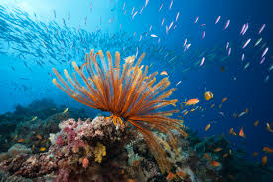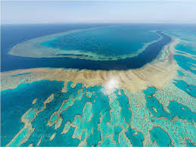

March 31 – Cairns (Yorkey’s Knob) Australia – Tropical North Queensland, surrounded on three sides by lush rainforest, is a great starting point for excursions to the Great Barrier Reef and other sites. Inland, you can explore the rainforest by cable car and scenic railway, soaring above treetops, peering into gorges, and observing jungle waterfalls. Feeling especially adventurous? Join a whitewater rafting adventure in Barron Gorge National Park! You can also stop at a rainforest village to see kangaroos, birds, butterflies, and reptiles. Hold a koala in your arms and feed a wallaby. Watch traditional Aboriginal dancers perform and artisans create their pottery, paintings, glass works, jewelry, and fabrics. You’ll find lovely keepsakes to bring home from your Cairns cruise.Back in town, stroll among the lovely native flowers, plants, and trees at Cairns Botanic Gardens. You might even get lucky in the local casino!

April 1- Port Douglas, Australia - The once-sleepy, now-bustling seaside village of Port Douglas will be your hub for exploring to the Great Barrier Reef. During your tour, you'll enjoy a full day of marine adventure with opportunities to swim, snorkel, dive or view the reef from an underwater observatory.

April 2 – Willis Island (cruising), Australia - The only humans that make their home on this tiny island—just 1,600 feet long and 490 feet wide—are meteorologists manning a weather monitoring station. From the ship’s deck you'll see thousands of seabirds such as Boobies, wedge-tailed shearwaters and sooty terns. Other highlights include a nearby coral reef and turtle nesting ground.
April 3 – at sea – Another day at sea to relax and enjoy the ship’s amenities while you rest up for your next excursion.

April 4 – Brisbane, Australia - Stopping at Brisbane, you'll find a thriving art scene, sandy beaches, lively nightlife, and multiple wildlife sanctuaries. Located almost halfway between the Gold and Sunshine coast regions, Brisbane is the capital of Queensland and Australia’s third-largest city. Go for a swim at South Bank Parklands - a sparkling, man-made, inner-city beach overlooking the Brisbane River. Or, take a ride down to Gold Coat and swim, surf, or build sandcastles on one of the Pacific's most famous beaches. Meet Australia’s best-known natives - the koalas and kangaroos - at the Lone Pine Koala Sanctuary on the river. Learn all about the sleepy marsupials and other wildlife threatened by traffic, disease, and habitat loss. Here you can cuddle a koala, feed a kangaroo and see Tasmanian devils. There’s no shortage of scenic vantage points in this port, whether it’s the observation deck on Mount Coot-tha, riding an enclosed capsule on the Wheel of Brisbane or along the stairs that lead you up the famous Story Bridge. Would you prefer to spend your time shopping? One chic area is Edward Street, where you'll find Hermès, Oroton, Georg Jensen, Paspaley, Chanel, and Australia’s largest Cartier store. Move on to James Street, in Fortitude Valley, for the vibrant colors, bold designs, and bohemian fashions of Australia's own Camilla.

April 5 – at sea – Rest, relax and enjoy life aboard the ship.

April 6 – Sydney – Disembarkation point

Cruise aboard the Celebrity Eclipse
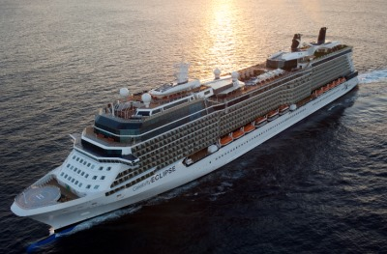

Aqua Class Balcony - $3334.14 pp*
Concierge Class Balcony - $2984.14 pp*
Oceanview Balcony – starting at $2634.14 pp*
*per person, double occupancy, includes all taxes and port fees
A deposit of only $450 per person holds your stateroom; final payment is due 10/27/21.

